Palayamanan: a holistic approach for sustainable intensification and diversification of organic rice-based farming systems for smallholders in the Philippines

Madonna Casimero¹, Rizal G. Corales², Myrna Malabayabas², Johannes Mendoza³

¹Senior Scientist, International Rice Research Institute
²Chief Science Research Specialist, Philippine Rice Research Institute
³ Researcher, International Rice Research Institute

Main text (Abstract).

The emergence of organic movement in the Philippines was a result of resistance to the Masagana 99 national rice program of the government in the 1970s which introduced Green Revolution technologies such as short maturing and high yielding rice varieties, high fertilizer input, and pesticides to control pests and diseases. This bundle of technology was promoted with loan facilities to buy the chemical inputs and farm machinery. The Masagana 99 program resulted in a rice production boom but it was also associated with increasing debts, poverty and food insecurity of smallholder farmers. This gave birth to the first organic movement, initiated by critical farmers, scientists and civil society groups, called Magsasaka at Siyentipiko para sa Pag-unlad ng Pagsasaka (MASIPAG). The first project was to retrieve traditional rice varieties that performed well without application of synthetic inputs. The private sector and non-government organizations came into play in the 1990s with the aim of reducing poverty among smallholder farmers by capitalizing on consumers’ interest in healthy and sustainable food from local producers.
In 2015, the country had 234,000 hectares of organic production area tilled by about 166,000 farmers and catering to the export market. In 2017, the Philippines ranked fifth in the number of organic producers with some 166,000 farmers growing various crops. Organic crop production remains anchored on a single crop (rice, banana, coffee, sugarcane, vegetables, coconut). There is a bigger opportunity for farmers to improve their livelihoods by taking advantage of the growing market for organically produced products by diversifiying their organic produce and by adopting a farming systems approach.
Palayamanan, coined from two Filipino words “palayan” and “kayamanan” which mean rice field and prosperity, respectively, is a development project initiated by the Philippines Rice Research Institute in 2000 that aimed to maximize utilization of resources, reduce farming risks, enhance farm productivity and sustainability, ensure household food security and economic stability of smallholder rice-based farmers. The Palayamanan embraces maximum utilization of on-farm biomass residues as nutrient source and animal feed with the help of microbial technology, as raw material for mushroom production and other value-adding products such as biodegradable seedling trays and pots. Sustainable intensification is implemented by diversifying the crops planted, with rice as the base crop, and integrated with fish and livestock to provide most of the food requirement and to stabilize the income of the farm family. The farm is divided into sections to accommodate the farm house, vegetable garden, and animal shed (0.05 ha); production area for rice-upland crop rotation, high value vegetables, rice-fish/rice-duck (0.75 ha) and the small farm reservoir (0.20 ha). The crop production practices include effective micro-organism (EM) technology, controlled irrigation, mulching, nutrient cycling of on-farm biomass and biological and/or natural pest control. For the livestock, raw or fermented feed supplement of on-farm biomass, mulch bedding, and automatic feeders/waterers are used. The net income derived from the Palayamanan farm is about 2 to 3 times more than conventional rice monocrop which is currently at USD 1,000/yr. The Palayamanan principles and approach towards sustainable intensification and diversification fits well in an organic food production system in response to consumers’ demand for diverse, healthy and safe food and the opportunity for smallholder farmers to capture a higher profit margin due to the premium price of organically produced foods.
The Philippine government sees organic agriculture as a high value business niche complementing the conventional agriculture sector. It has established enabling mechanisms to support organic crop production through the enactment of the Organic Agriculture Act of 2010 (Republic Act 10068). The Department of Agriculture (DA) established the National Organic Agriculture Program (NOAP) that outlines concrete strategies to develop the organic sector and the Organic Agriculture Production Standards for Crops that guide farmers on Good Agriculture Practices (GAP). In December 2020, the law was amended by Republic Act 11511, which included provisions on establishing an educational and awareness campaign to promote organic food, adopting the “Participatory Guarantee System” for certifications, and ensuring proper market access to producers to ensure decent prices. Also, there is an increasing involvement of the private sector in the organic food value chain, especially in helping smallholders access the export market. However, the organic crop subsector is still challenged by the cost of third party certification.
The time is right to bring Palayamanan to scale. Capacity development needs to be done with the current Palayamanan farmers as well as other farmers that have not embraced diversified farming as a system for organic crop production. Advocacy is required so that more farmers will adopt the organic Palayamanan.

Key words: Palayamanan, sustainable intensification, diversification, rice-based farming systems

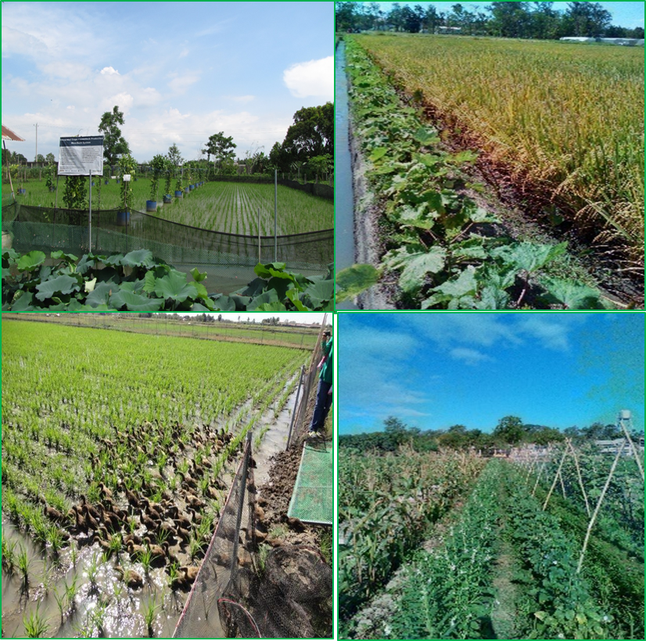
Figure 1. Crop and animal components in the Palayamanan farm at the Philippines Rice Research Institute, Munoz, Nueva Ecija, Philippines.

Co-responding author: Madonna Casimero
Position: Senior Scientist
Affiliations: International Rice Research Institute
Country: Philippines
E-mail :m.casimero@irri.org
Abstract Example

Hanako Nihon¹, Taro Nippon²

¹Graduate School of Agricultural Science, Tohoku University
²National Agricultural Experiment Station

The conference aims to stimulate and foster exchanges between scientists, rice growers and other stakeholders in the organic rice production and commercialization chain. These exchanges, focused on organic rice production in different regions throughout the world, will be organized to 1) collect and assess practical knowledge and functions of current organic rice production systems, 2) discover applied innovations and identify obstacles that hinder further development of the systems, 3) analyze the impact of different types of organic rice production on food quality, health, and the environment, 4) strengthen the international innovation network on sustainable rice production, and 5) explore the issues, levels, and consequences of a scale shift toward the mainstreaming of organic agriculture throughout the agri-food chain.
With regards to the background of the International Symposium on Organic Rice Production Systems, the 1st International Symposium on Organic Rice Production Systems was held in September 2012 by the Montpellier Center of the French National Agricultural Research Institute. Since 2000, the center has been conducting participatory research in collaboration with farmers, focusing on the promotion of organic rice in the Camargue region, which extends to the delta at the mouth of the Rhone River. The symposium was planned to make an international comparison of organic rice production systems based on the outputs of this research. This aim was shared among the participants, and the second was held in Milan, Italy in September 2015 in the framework of the International EXPO Feeding the Planet, Energy for Life. The third was held in Porto Alegre, Brazil in March 2018. The 4th International Symposium had been scheduled to be held in August-September 2021, but it was decided to postpone it due to the Covid 19 pandemic, various obstacles to participation from overseas.

Fig. 1. Relationship between X and Y.

Key words: double cropping, environment, soil, tillage, weed

Co-responding author: Taro Nippon
Position: Director
Affiliations: National Agricultural Experiment Station
Country: Japan
E-mail : t.nippon@tohoku.ac.jp

